**Resource allocation and Task scheduling in IoT /Fog/Cloud network based on PSO Algorithm:**

**Architecture:**

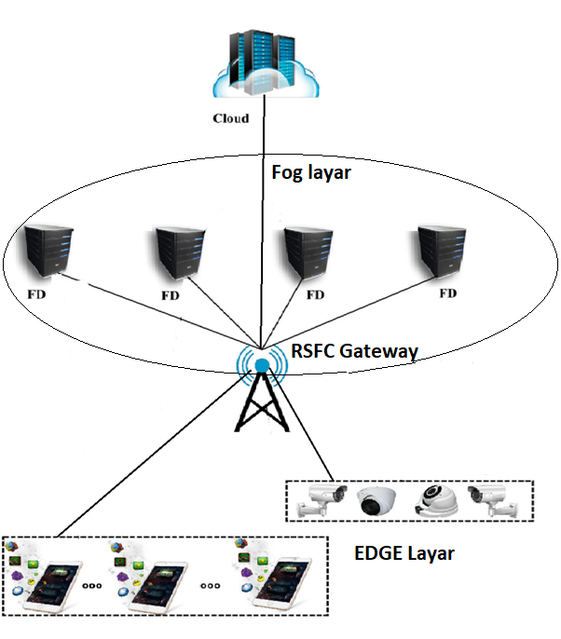

**RSFC(ResourceScheduler-FogCloud) Gateway: has 4 modules in it:**

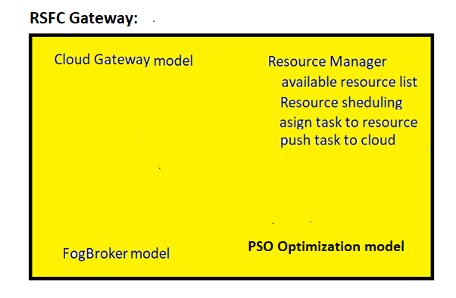

1. **Fog Broker model:** it establishes the connectivity with the IoT devises and receives task and forward them to Resource manager
2. **Resource Manager model:** it maintains the list of available fog devices/resources for that slot. when tasks are received from fog broker by resource manager, it uses **PSO Optimization model** to schedule or priorities tasks for assigning the resource. If any task left with unassigned because of not availability of resource then that selected task will be uploaded to cloud via Cloud gate way.
3. **Cloud Gateway model:** it establishes the connectivity to cloud and used by Resource manager to upload the tasks if resources are not available for that particular task during that slot.
4. **PSO Optimization model:** algorithm implemented to schedule and select the task for resource allocation. This model is used by Resource Manager model.

**Simulation Graphs:**

1. Number of IoT devises (Tasks) vs Latency
2. Number of IoT devises (Tasks) vs Network Utilization